 | 8th Grade Supplies
 | Must Haves
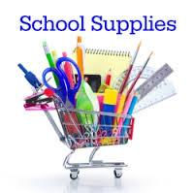 | Pencils/Pens  Lined Paper  Binder/Folder System  Agenda/Planner (we provide one)  2-3 spiral notebooks  Backpack/Bookbag
 | Nice to Have
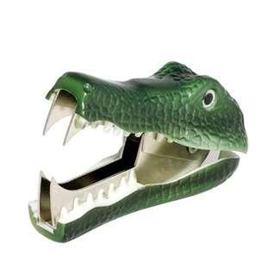 | Sharpies (black and color)  Earbuds/Headphones  Calculator  Post-it-Notes  Highlighters  Water Bottle
Dear Eighth Grade Students and Families,

Here’s a list of our suggestions for supplies to make your 8th grade year successful. Please enjoy your remaining summer vacation days!

We’ll see you in a few weeks!

Mrs. Bell, Mr. Brown, Mrs. Button, Mrs. Lamothe, and Mrs. Robbins

